DAWT ASSIGNMENT-1

SUPERMARKET SALES VISUALIZATIONS

NAME: G.GOWRI PRIYA

Bubble Chart- Gross Income by City

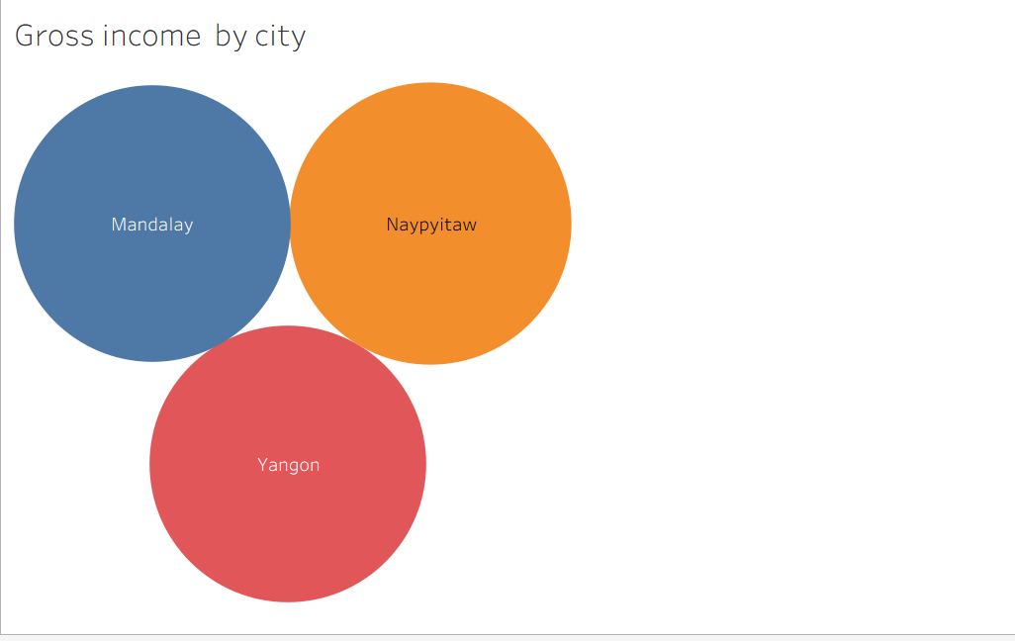

Line Chart – Total Sales Over Time

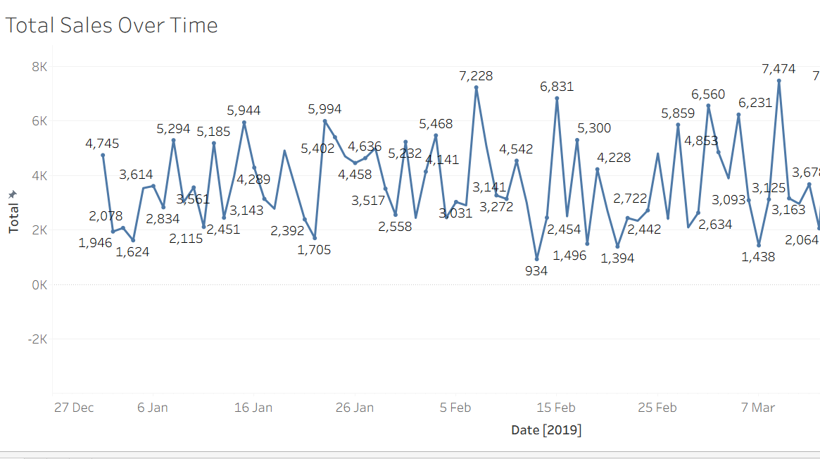

Stacked Bar Chart – Quantity Sold by Branch and Gender

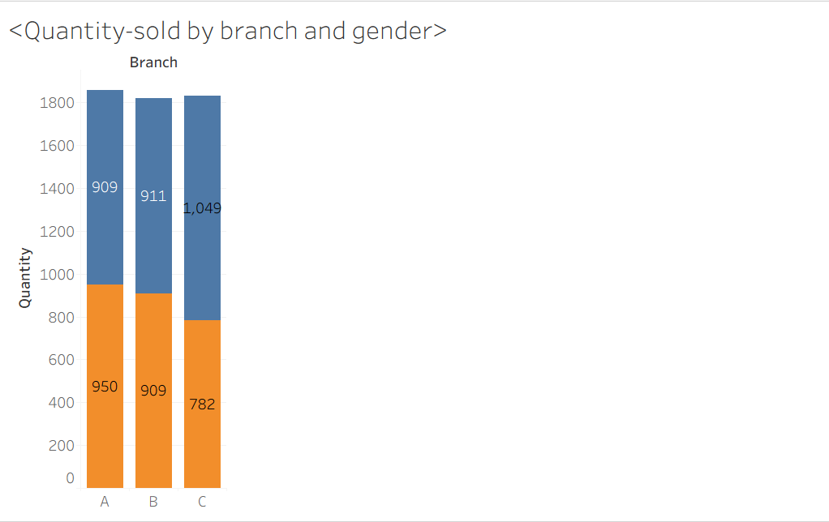

Pie Chart – Sales Distribution by Payment Type

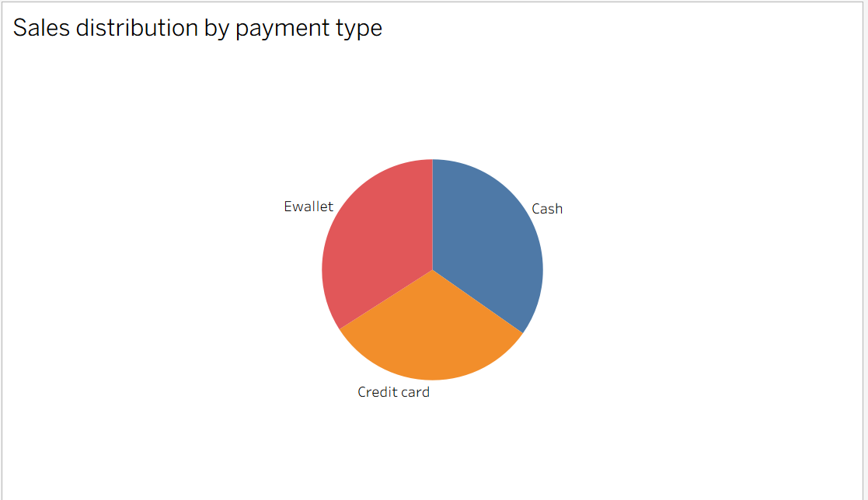

Bar Chart – Gross Income by Product Line

